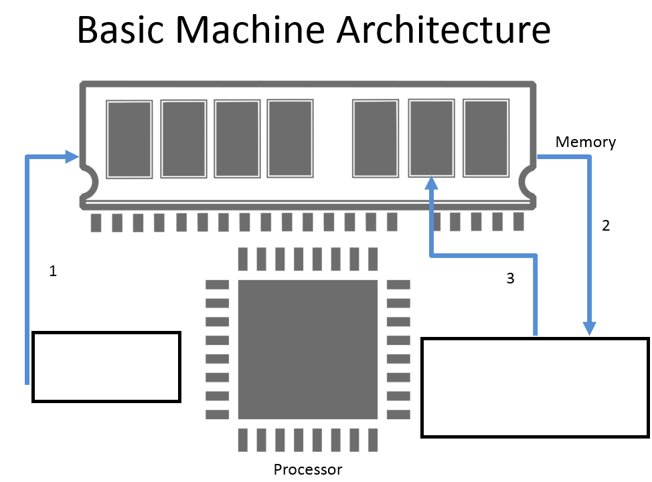
Figure 2 – The Basic Machine Architecture

- List at least 5 different primitive data types used this semester and provide example of each one.
Int, double, byte, short, long, float
- List at least 5 different complex data types used this semester and provide example of each one.
String
- Given the following program, what is the output?
public static void main(String[] args)
{
int a = 3;
int b = 4;
System.out.print(" " + 7 + 2 + " ");
System.out.println(a + b);
System.out.print(" " + a + b + " ");
System.out.println(foo() + a + b + " ");
System.out.println(a + b + foo());
}
public static String foo()
{
return "foo";
}

Section 2 – Conditional Statements
- Describe the 3 conditional operators.
AND = && , OR = ||, NOT = !

- Fill out the truth table below:
X | Y | Z | X && (Y || Z)
True | True | True | True (True)
True | True | False | True (True)
True | False | True | False (True)
True | False | False | False (False)
False | True | True | False (True)
False | True | False | False (True)
False | False | True | False (True)
False | False | False | False (False)

AND as well as (OR)

Section 3 – Looping
- What is the difference between the while loop, the for loop, and the do-while loop?
A while loop tests for a condition as long as it remains true, a for loop tests for a condition only for a limited number of times as desired, and finally, a do while loop runs from at least once to an infinite number of times.
- Explain how does the Monte Carlo simulation work?
Monte Carlo simulation performs risk analysis by building models of possible results by substituting a range of values—a probability distribution—for any factor that has inherent uncertainty. It then calculates results over and over, each time using a different set of random values from the probability functions.
- Below is the summation symbol used in mathematics to demonstrate the sum of a set of numbers.

Figure 3 – The Summation Symbol for n
In the above image, n represents how many numbers are in the set of numbers. Everything to the right of the summation symbol (sigma, ) is what is added each time and i represents the counter at that time. If, for example, n was 10, the above image would represent the sum of all digits starting a 1 to 10, which is 55 (1 + 2 + 3 + 4 + 5 + 6 + 7 + 8 + 9 + 10).

Implement this as a method in Java, assuming n equals 10.

- Given the following code, how many times does the println statement happen?
for(int i = 0; i < 100; i++)
{
for(int j = 0; j < 20; j++)
{
System.out.println(i*j);
}
}
2000 times

Section 4 – Arrays/Strings
- Given the list above, what is the index of 50?
- The index is 6

- Assuming the array is stored in the variable named list, what do the following commands produce?

Command | Output
list.indexOf(50) | 6
list.indexOf(51) | 0
list.length | 13

- Some Java programmers use int list[] instead of int[] list to declare arrays. What's the difference?
int[] list declares the “list” and following variables as an array, while list[] declares only itself as a “int” array.
- If list[] is an array, why does System.out.println(list) print out a hexadecimal integer, like @f62373, instead of the elements of the array?

- Write a program that declares and initializes an array a[] of size 1000.
  - Does your program compile?

  - What is the value of a[500]?

  - What is the value of a[1000]?

  - What happens when you attempt to access a[1000]?

- Design a method that will print the array list designed above in reverse order, without using .reverse().

- How would you implement the following multidimensional array?
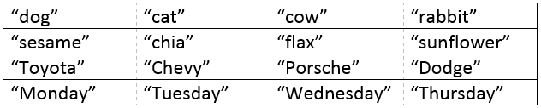
- What is the array address of each element in the above array?

- What do the following commands produce?
Command | s | Output
s.length() | Hello | 5
s.charAt(1) | Hello | e
s.substring(1, 4) | Hello | ell
s.substring(1) | Hello | ello
s.toUpperCase() | Hello | HELLO
s.toLowerCase() | Hello | hello
s.startsWith("http:") | http://www.cnn.com | true
s.endsWith(".com") | http://www.cnn.com | false
s.indexOf(".java") | Hello.java.html | 5
s.indexOf(".java", 6) | Hello.java.html
s.lastIndexOf(".") | Hello.java.html
s.trim() | " Hello there "
s.replace(",", "-") | 1,800,867,5309 | 1-800-867-5309

- When working with String data types, why should I avoid doing s == “test”?
  - What should be used instead?
  - .equals()

- What is the difference between mutable and immutable?
Mutable is changeable, such as ( int x = 5, x = 10). Immutable cannot change, such as (String s = “Hello”; s[0] = “J”;)
- Give a word that matches the regular expression: “[^bcdefghiklmnopqrstuwxyz]{4}”
java
- What does the following code fragment print? Why?
String s = "Hello World";
s.toUpperCase();
s.substring(6, 11);
System.out.println(s);

